Name: K Subrahmanyam
RegNo: 192312521

ITA0602 – MACHINE LEARNING
SDG 1 ASSIGNMENT
Q14. Explain How Machine Learning Predicts Water Quality Using Sensor Data
1. Problem Statement
Water quality needs to be continuously monitored to determine whether water is safe or unsafe for use. Manual testing takes time and cannot provide continuous monitoring.
Machine Learning can analyze sensor readings and predict the quality of water automatically.
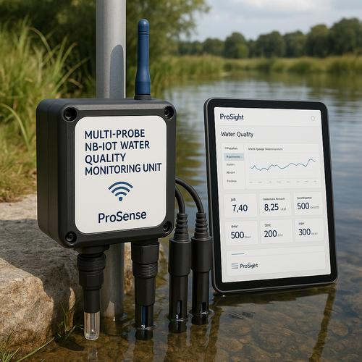
2. Sensor Data Used
Sensors can collect parameters such as:
- pH
- Temperature
- Turbidity
- Total Dissolved Solids (TDS)
- Electrical conductivity
- Dissolved oxygen
These values are used as input features for the Machine Learning model.
3. Machine Learning Process
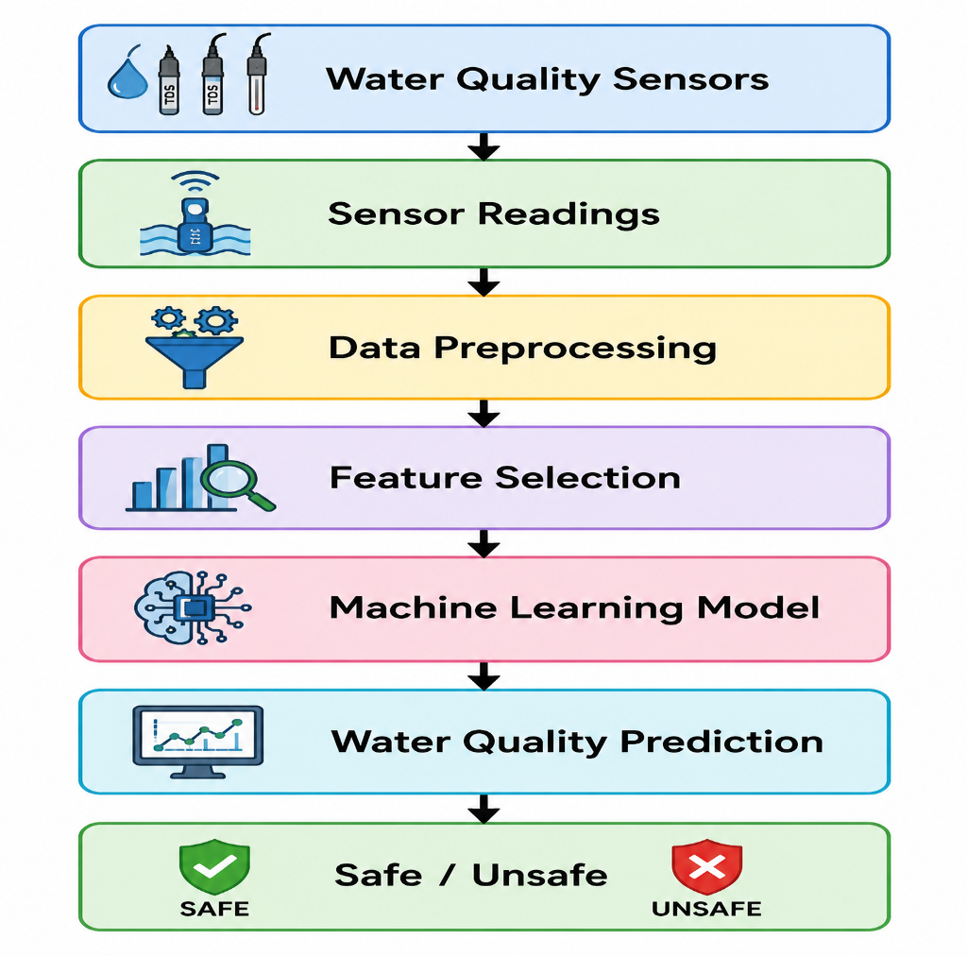
4. Data Preprocessing
Before giving the sensor data to the model:
- Missing values are handled.
- Noisy readings are removed.
- Data is normalized if required.
- Incorrect sensor readings are identified.
- Important features are selected.
This improves the reliability of the prediction.
5. Suitable Machine Learning Algorithm
A Decision Tree can be used to classify water as Safe or Unsafe.
For example:
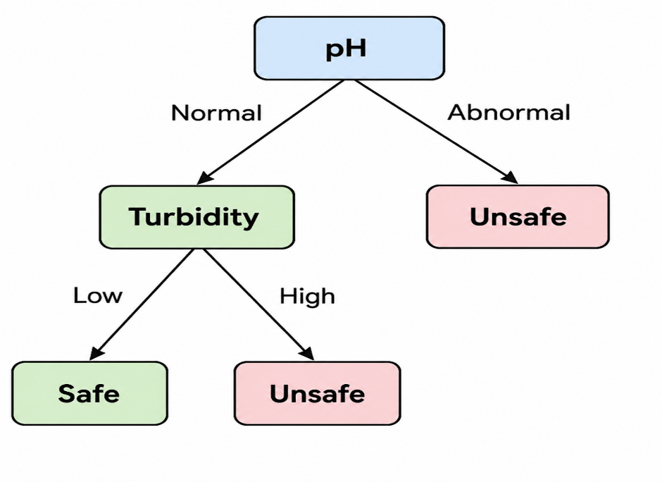
The Decision Tree uses sensor parameters to make a sequence of decisions and finally classify the water quality.
6. Training and Prediction
Historical sensor data with known water-quality labels is used for training.
Example:
pH | Turbidity | TDS | Water Quality
7.0 | Low | Low | Safe
6.8 | Low | Medium | Safe
5.5 | High | High | Unsafe
8.5 | High | High | Unsafe
The trained model can then receive new sensor readings and predict whether the water is Safe or Unsafe.
7. Advantages
- Provides continuous water-quality monitoring.
- Detects abnormal conditions quickly.
- Reduces dependence on manual testing.
- Helps identify possible contamination.
- Supports early warning and decision-making.
8. SDG Connection
This application supports Sustainable Development Goal 6 (SDG 6) – Clean Water and Sanitation, because ML-based water-quality monitoring can help improve access to safe and clean water.
Conclusion
Machine Learning can use pH, turbidity, TDS, temperature, and other sensor readings to identify patterns in water quality. A Decision Tree can classify the water as safe or unsafe, allowing continuous monitoring and early detection of poor water quality. This provides a practical application of Machine Learning for clean-water management.
Short flow to remember for exam:
The assignment's expected deliverables also emphasize identifying the problem, input features, target output, selecting and justifying an ML approach, explaining the workflow, and discussing outcomes and practical applications.

